Sunday Evening Classics
03 September 2017
8:00 p.m.
Tel-Aviv Wind Quintet
Roy Amotz, Flute
Yigal Kaminka, Oboe
Danny Erdman, Clarinet
Nadav Cohen, Bassoon
Itamar Leshem, Horn

**Program**

M. Ravel (1875-1937) Pièce en forme de Habanera
Arr. Clarke S. Kessler

K. Weill (1900-1950) Songs from the Threepenny Opera
Arr.: Alan R. Kay
Overture
Salomon Song
Ballad of Gracious Living
Song of the Insufficiency of Human Endeavor
Ballad of Mack the Knife

J. S. Bach (1685-1750) Trio Sonata in F, BWV 525
Arr. Mordechai Rechtman
Allegro Moderato
Adagio
Allegro

W. A. Mozart (1756-1791) Adagio and Allegro in f minor, K. 594
Arr.: Milan Munclinger

L. Berio (1925-2003) Opus Number Zoo
Hebrew version: E. Shefi, Tel-Aviv Wind Quintet; direction: Ari Teperberg
Barn Dance
The Fawn
The Grey Mouse
Tomcats
NEXT CONCERTS:
Sunday 10 September: Trio “ALEF” for Clarinet, Bassoon and Piano

To thank tonight's artists, please contribute generously in the gallery after the concert. Your entire donation will be given to the performers.

The Tel Aviv Wind Quintet was founded in 2009, seeking to bring existing repertoire as well as commissioned works to wider audiences. Today, the Quintet performs more than 20 concerts each season throughout Israel’s most prestigious concert venues, together with cultural and educational activities in the periphery. In June 2017 the TAWQ went on its first international tour in Switzerland. The Quintet was awarded the Eilam prize for Israeli performers (2011), as well as grants from the Rabinovich Foundation for the Arts, Haifa Arts Foundation and the Mifal Ha'Pais Council for Culture and Arts. The group performs and records music by leading Israeli composers of both the younger and the older generations.
The TAWQ's debut album was released at the end of 2016, and a second CD, with pianist Yaron Kohlberg, will be released in autumn 2017.

Roy Amotz (Flute) studied in Israel with Vladimir Silva, Moshe Epstein, Yossi Arnheim and Avner Biron. He continued his studies at the Hochschule für Musik und Darstellende Kunst, Stuttgart, with Jean Claude Gérard and at the University of Arts, Berlin with Roswitha Staege where he received his soloist Diploma with honors in 2013. Roy won first prize in the International Flute Competition in Volos, Greece and in the Pergamenchikow Competition in Berlin with "Trio Vis". He is the Flutist and the European projects manager of the acclaimed Meitar Ensemble. Roy has played as a principal player in the Israel Symphony Orchestra, Rishon le'Zion; He is is a member of the Verbier Festival Chamber Orchestra since 2007 and as from September 2013, principal flautist of the Geneva Camerata..

Danny Erdman (Clarinet) has performed across Israel, Europe, and the U.S. both as a soloist and a chamber musician. The youngest artist to perform at the first EuroCass convention in 1997, Danny has also participated in festivals such as Ostend, Paris, Norfolk, Sarasota, and Aspen. Following the completion of his Bachelor degree at Tel Aviv University and his Master degree at Yale University, Danny won the position of the principal clarinetist at the Israel Chamber Orchestra. An avid chamber and new music performer, he is now a member of the 'Israel contemporary Players' ensemble. Danny served in the IDF as an "Outstanding Musician". Since 1996 he had been a recipient of the America-Israel Cultural Foundation scholarships. Among his mentors are Eva Wasserman, Ron Selka, and David Shifrin.

Yigal Kaminka (Oboe) holds a double M.A degree and a third degree in Oboe and Recorder from the Karlsruhe University, Germany. He performed as both a soloist and as principal oboist in various orchestras, including the Budapest Festival Orchestra, the Jerusalem Symphony Orchestra, Daniel Barenboim’s West-Eastern Divan and the Israeli Philharmonic Orchestra. Yigal has won numerous scholarships and competitions, including the 2009 “Aviv Competition,” where he won the first prize in all 3 possible categories. In 2010, Yigal founded JoyTunes, a startup company developing new technological solutions to music education. The company has grown to have over 3 million users in more than 110 countries and has been awarded a prestigious U.N. award.

Itamar Leshem (Horn) was born in Israel and started playing the horn by the age of 12. He has graduated the Jerusalem Academy of Music and the Roosevelt University, studying with Mr. Dale Clevenger in Chicago. His studies were supported by the America-Israel Cultural Foundation scholarships. Itamar is performing regularly with the Israel Philharmonic Orchestra and recently performed with them as a soloist under the baton of Zubin Mehta in Israel and on tours in South America and Europe.​ Itamar is a member of the West-Eastern Divan orchestra directed by Daniel Barenboim and a member of the Israel Symphony Orchestra, Rishon le'Zion. Itamar has performed in some of the most distinguished festivals such as the Salzburg Festival, Lucerne Festival, the Proms, Jerusalem Chamber music Festival, Landsberg Chamber music Festival and in venues including Carnegie Hall, Teatro Colon, La Scala and others. Lately performed the Strauss concerto in addition to lectures and recitals in China.

Nadav Cohen (Bassoon) was born in 1983, Nadav Cohen studied bassoon at the Jerusalem Academy for Music and Dance with Uzi Shalev and Mauricio Paez, and composition with Yinam Leef. He continued his bassoon studies with Ole Kristian Dahl in Cologne in addition to baroque bassoon studies with Donna Agrell in the Royal Conservatory in the Hague. He served in the IDF as an Outstanding Musician and received scholarships from the America- Israel Cultural Foundation, the Ronen Foundation as well as the Jerusalem Music and Dance Academy President's Award. Nadav was Principle Bassoon of the Israel Camerata Jerusalem. He was a participant of the International Ensemble Modern Academy in Frankfurt 2012-13 and he continues to perform regularly with Ensemble Modern. A member of Le Concert Impromptu ensemble in Paris 2014-17 and currently a member of the Tel-Aviv Wind Quintet and the Meitar Ensemble for contemporary music.

Note: if you need to leave during the performance,
please wait for applause before returning to your seat.

Smoking is not allowed in the building or on the grounds.

Please, no use of cellular telephones or
flash photography during the performance.

Guided Tours of the Jerusalem Center
Wednesday, Thursday, Friday
Morning: 10:00, 10:30, 11:00, 11:30
Afternoon: 2:00, 2:30, 3:00, 3:30

Groups of ten or more people by appointment: call 02-626-5666
For concert information, please write to concerts@jc.byu.ac.il

Sunday Evening Classics

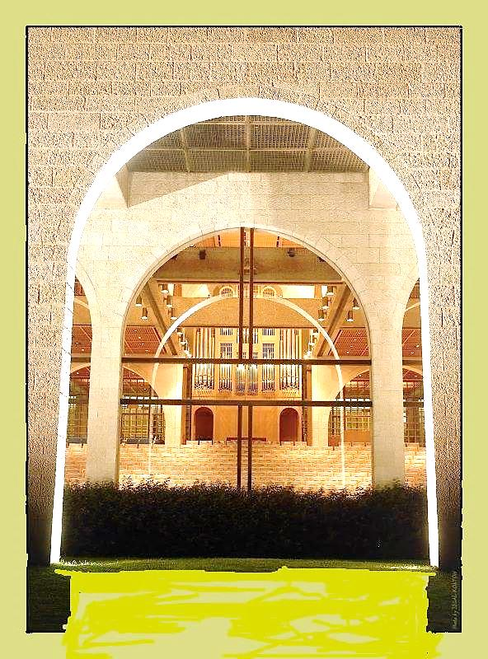

The Jerusalem Center For Near Eastern Studies
Brigham Young University (Mormon University)

P.O. Box 19604
Jerusalem 91196

***
The Jerusalem Center Concert Series is funded in part by a grant from Charles and Randi Wax of San Diego, California, USA.

